# Exercises: Creating Landing Pages

## Code Mesh Conference

Create a Web page (HTML5 + CSS3 + images) that looks and behaves like the screenshots below:

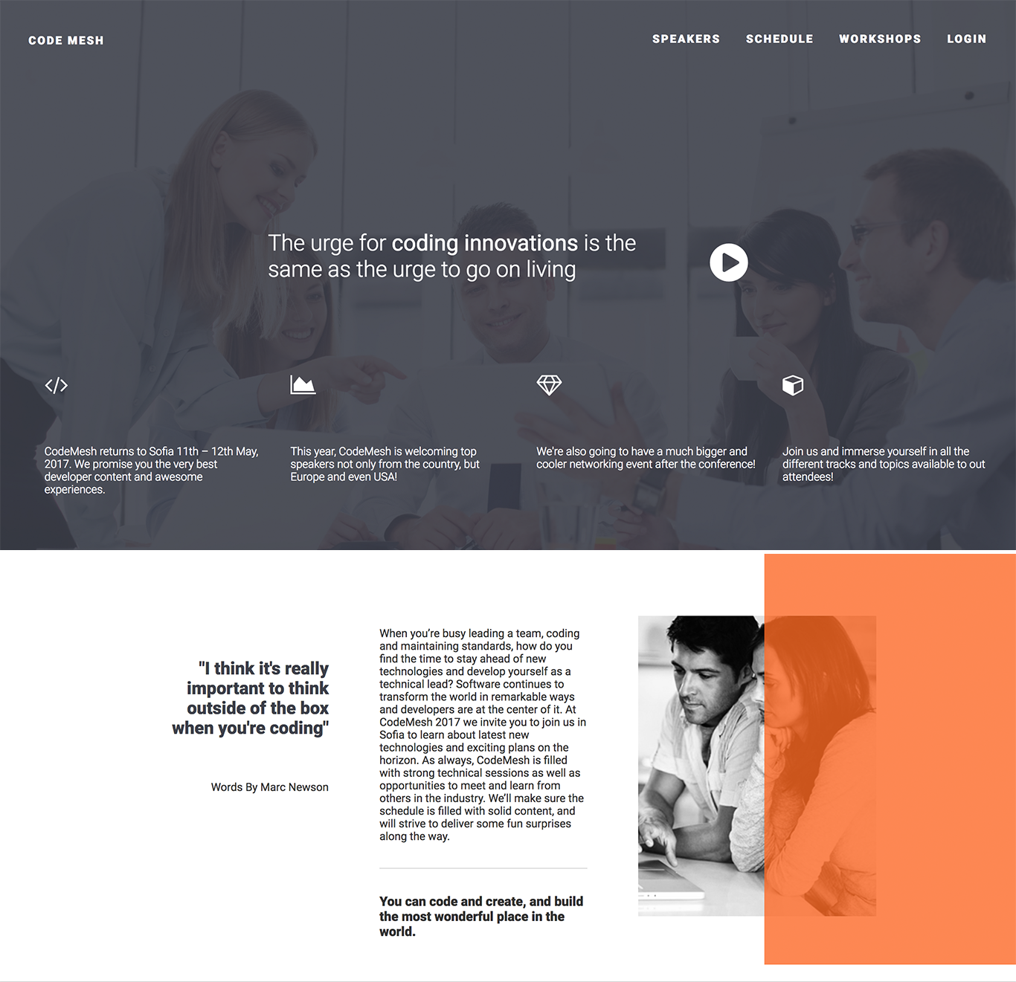

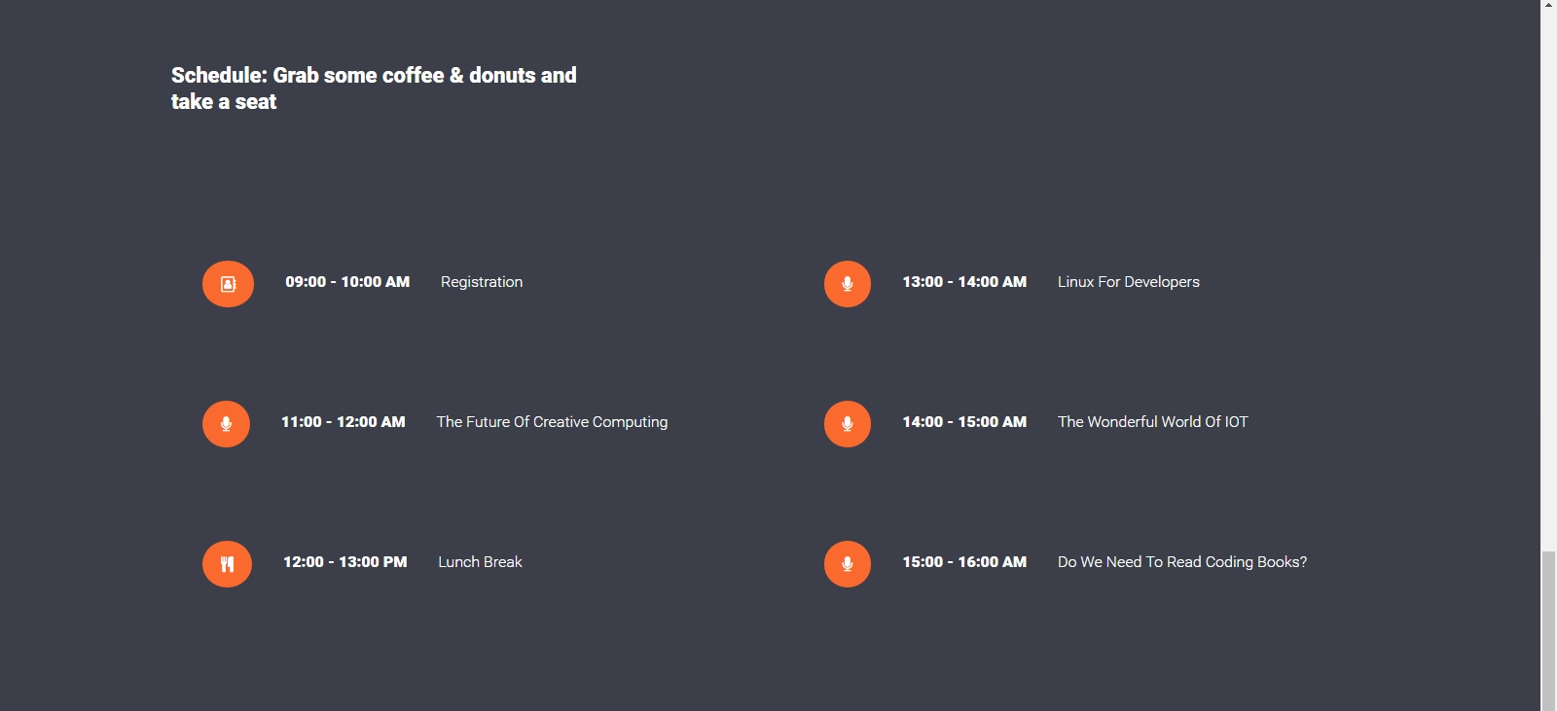

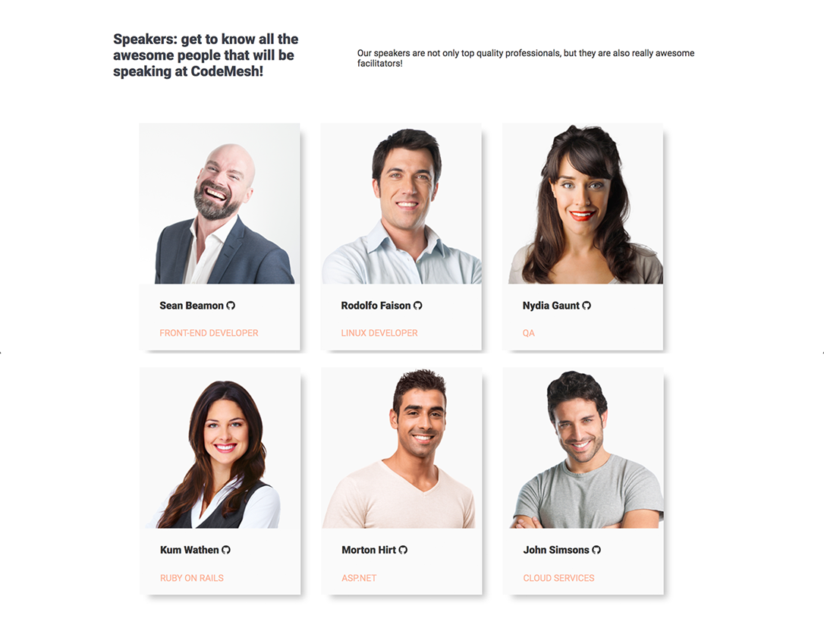

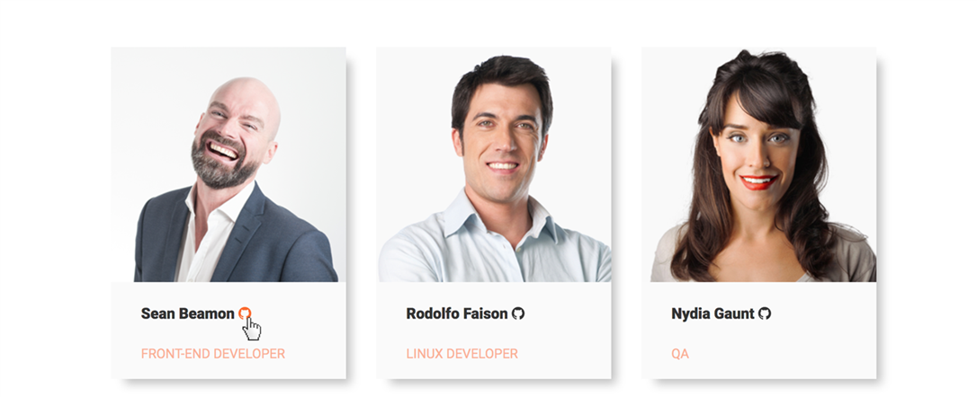

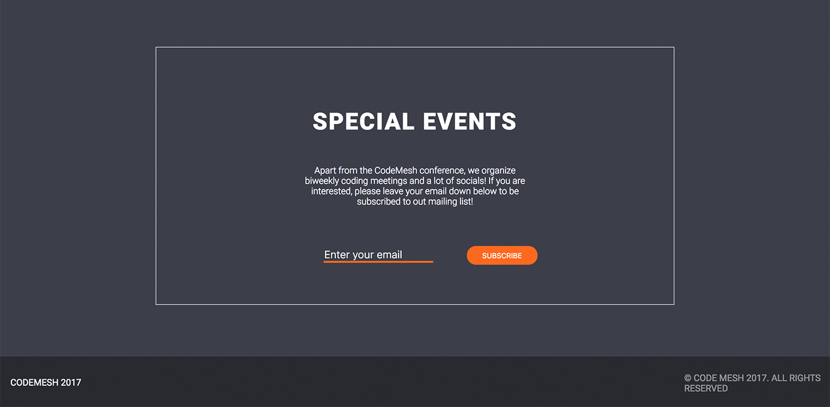

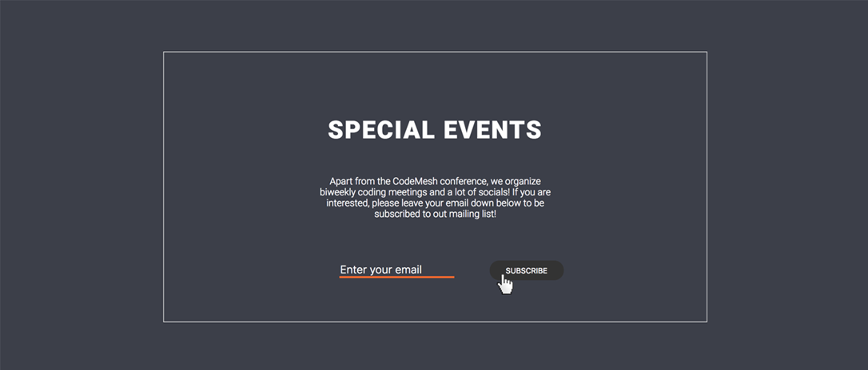



* The mouse cursors in the above screenshots explain what happens when the mouse moves over a project Start

### Input

You are given the above screenshots + the required font + all required images + the texts on the site.

### Output

The output should be valid HTML5 + CSS3 that implement the above Web site.

### Constraints

* Font: 14px “Roboto“,sans-serif;
* Background Colors: #ffffff, #3c3f49;
* Colors: #333333; #3c3f49; #fa692e;
* Pixel-perfect implementation is not required.

### Hints

Use the following **font**, **styles** and **CSS definitions** for the icons in the header, the icons in the schedule section and the GitHub links on the speakers section

* @import url('<https://maxcdn.bootstrapcdn.com/font-awesome/4.7.0/css/font-awesome.min.css>');
* <i class="fa fa-play-circle fa-4x" aria-hidden=“true"></i>
* <i class="fa fa-code fa-2x" aria-hidden="true"></i>
* <i class="fa fa-area-chart fa-2x" aria-hidden=“true"></i>
* <i class="fa fa-diamond fa-2x" aria-hidden=“true"></i>
* <i class="fa fa-cube fa-2x" aria-hidden="true"></i>
* <i class="fa fa-angle-down" aria-hidden=“true"></i>
* <i class="fa fa-address-book-o orange-icon" aria-hidden=“true"></i>
* <i class="fa fa-microphone orange-icon" aria-hidden=“true"></i>
* <i class="fa fa-cutlery orange-icon" aria-hidden=“true"></i>
* <i class="fa fa-github" aria-hidden="true"></i>

For the **speaker boxes** you may use:

* box-shadow: 10px 10px 15px -5px rgba(0,0,0,0.25);

For the **overlay on the header,** look up CSS background-image properties.

For the **overlay on the introduction section,** you may use a pseudo class or additional divs.

For **the sections that are full width,** they need to be expanded to the full width with the help of pseudo elements. **DON’T make the body width: 100% and fix the other containers with paddings.**